How to upgrade for CRY2600 Series
- Copy the the firmware file into the root directory of SD card;
- Insert the SD card to the device;
- Click ‘system’ from the main interface of the device;
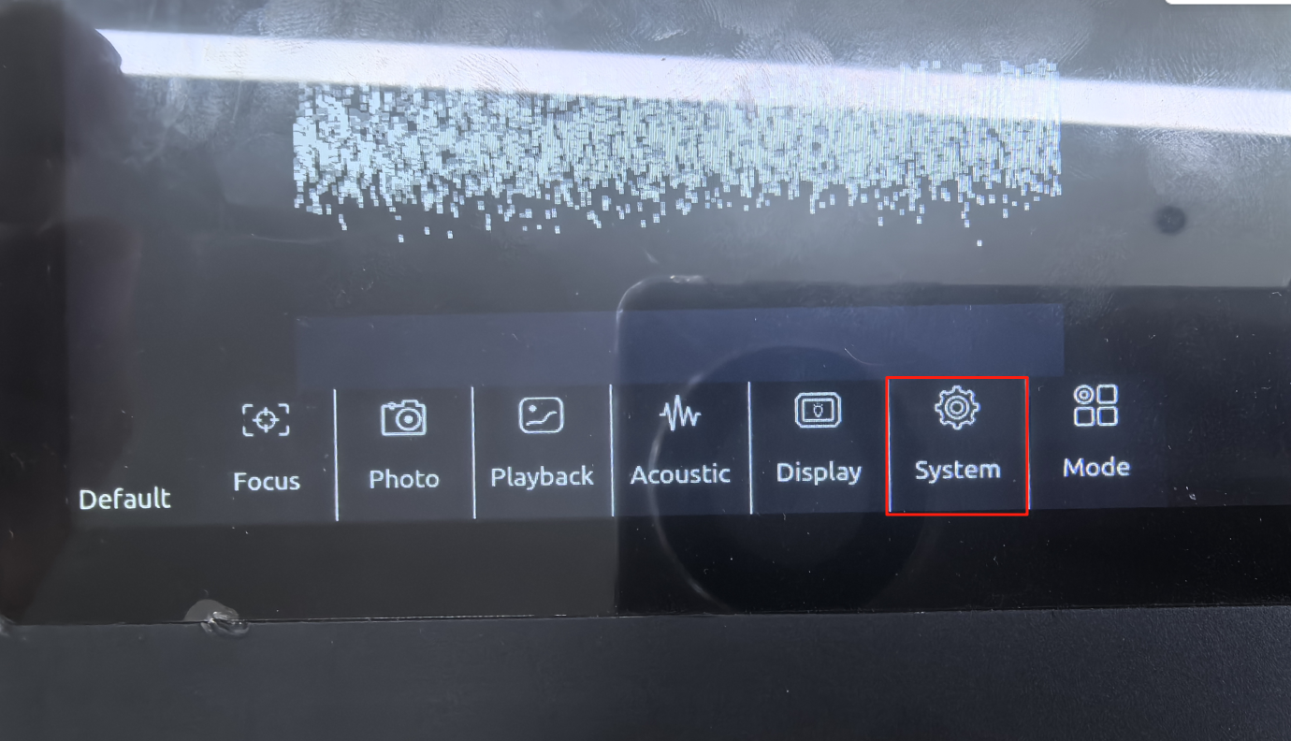
4.And then click ‘Tool’, you can see there will be ‘Upgrade’;
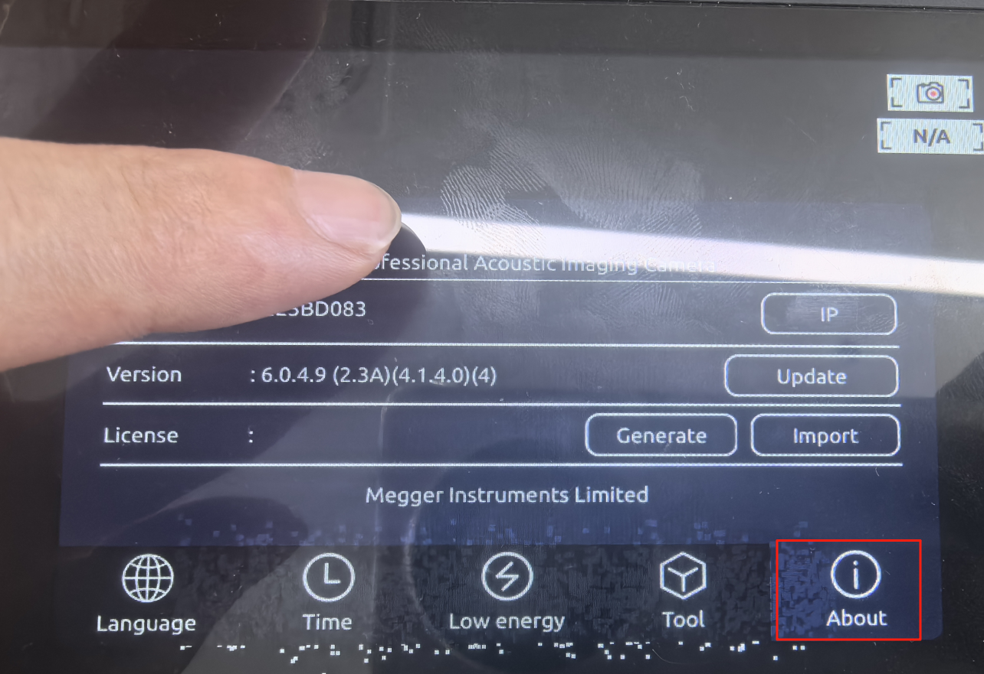
5.Click ‘upgrade’.
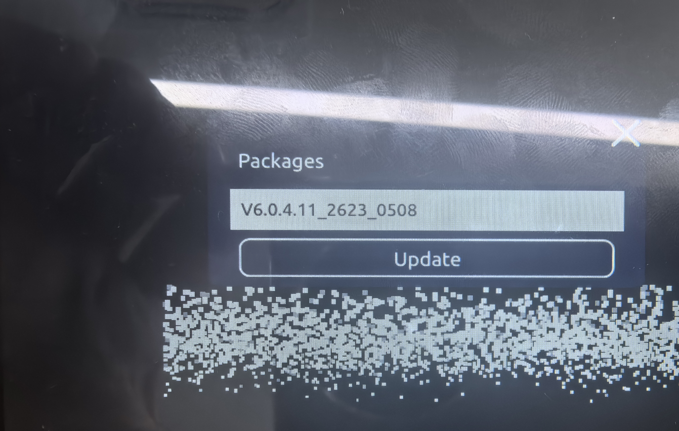

Latest firmware downloading link:
CRY2623: CRY2623
CRY2624: CRY2624

